

Subject: Programming with Java
ASSIGNMENT No : 10
TITLE :Write a Java program to demonstrate the use of abstract classes and abstract methods
NameL:Avdhoot Mohite Class: CSE A3
PRN:25070122056 Batch:25-29
Problem Statement
Write a Java program to demonstrate the use of abstract classes and abstract methods
Learning Objectives
To implement abstraction using abstract classes and abstract methods.
Theory
Abstract classes provide partial implementation of a program and cannot be instantiated directly. They may contain both abstract and concrete methods. Abstract methods declare functionality that must be implemented by subclasses. Abstraction hides implementation details while exposing only essential functionality. This improves code flexibility and maintainability in object-oriented programming.
Outcome
After completing this experiment, we learned how to implement abstract classes and abstract methods in Java. We understood that an abstract class cannot be instantiated directly and that abstract methods must be implemented by its subclasses. This experiment improved our understanding of abstraction and its role in achieving code reusability, flexibility, and maintainability in object-oriented programming.
Conclusion
The experiment successfully demonstrated the use of abstract classes and abstract methods in Java. It showed how abstraction hides implementation details while providing a common structure for subclasses. Using abstract classes improves code organization, reusability, and maintainability, making Java applications more flexible and easier to manage.
Exercise
1.Create an abstract Payment class and implement Credit Card and UPI payment classes.?
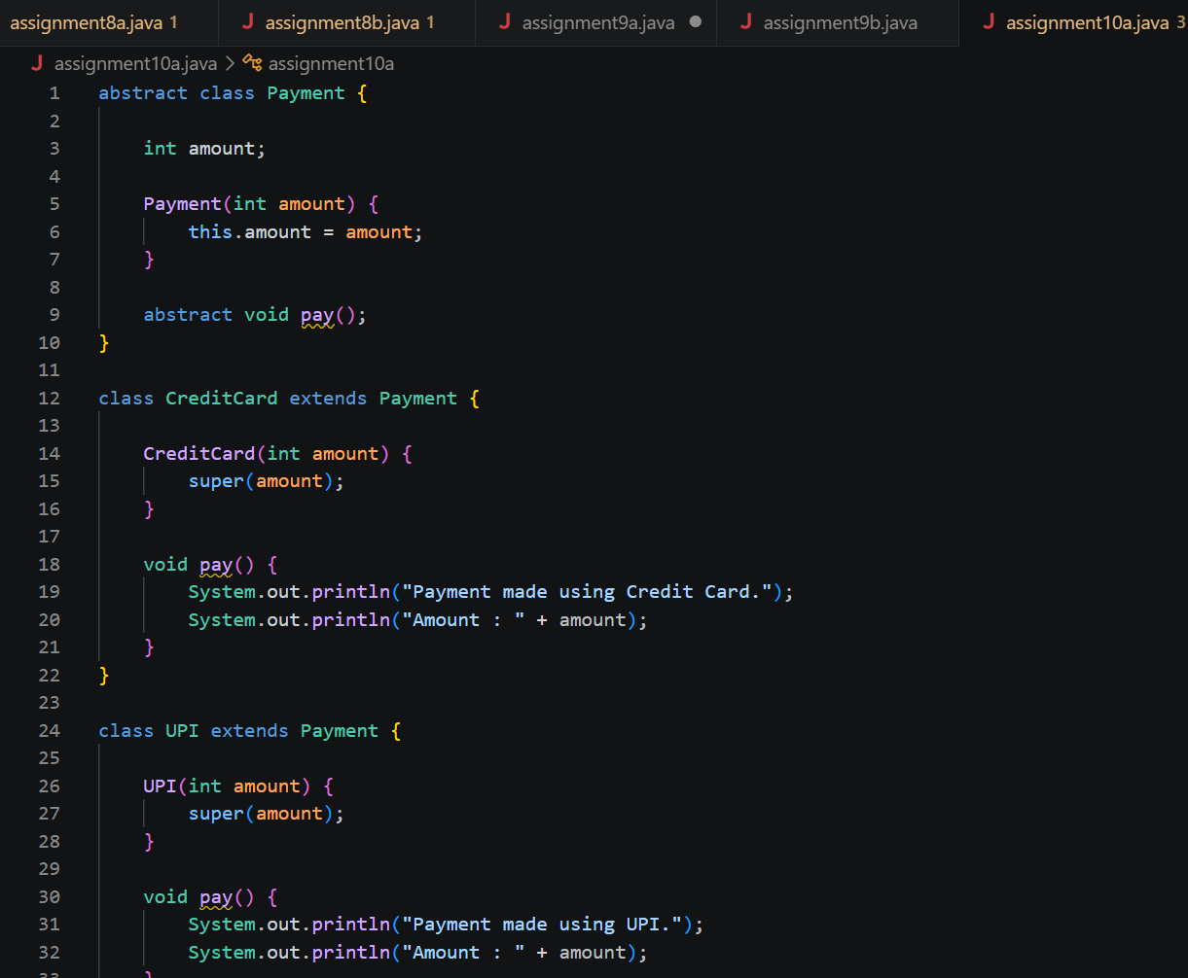
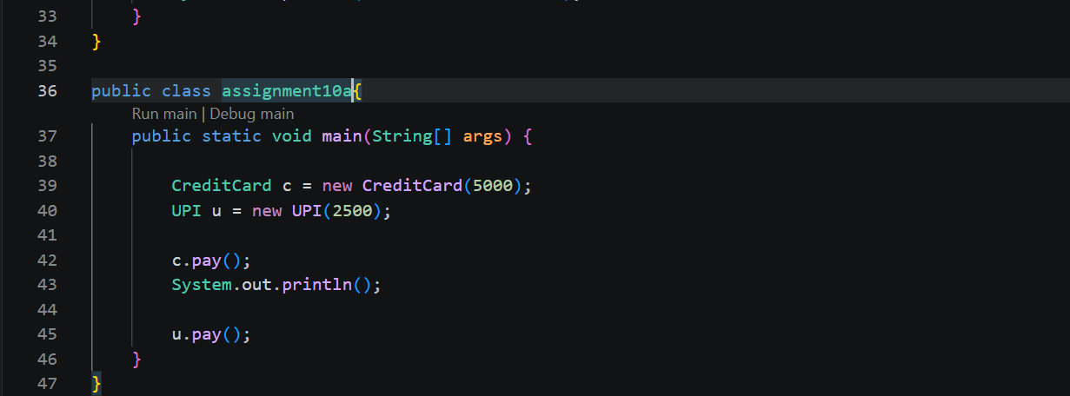
Output:
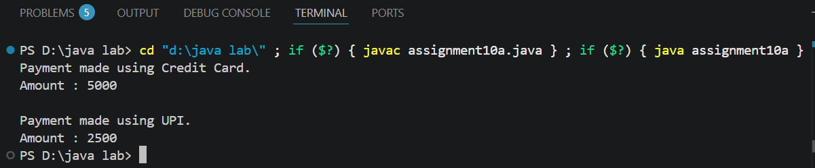
2. Create an abstract FoodOrder class with an abstract method calculateBill(). Implement two subclasses, DineInOrder and TakeAwayOrder, to calculate and display the total bill based on the order type
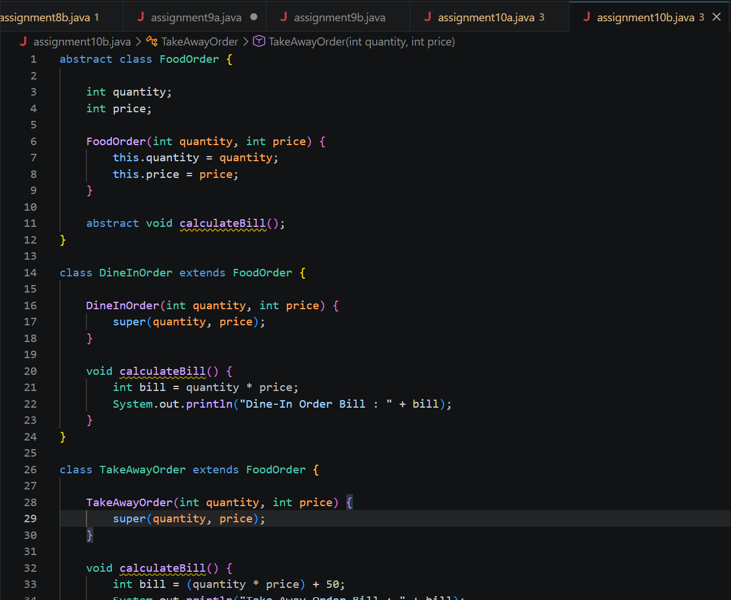
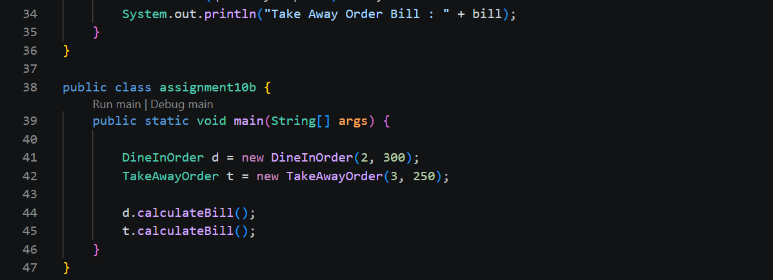
Output:
